MODULE 1
1. Read from STDIN, Write to STDOUT | Basics of Input/Output & Basic Programming Practice Problems
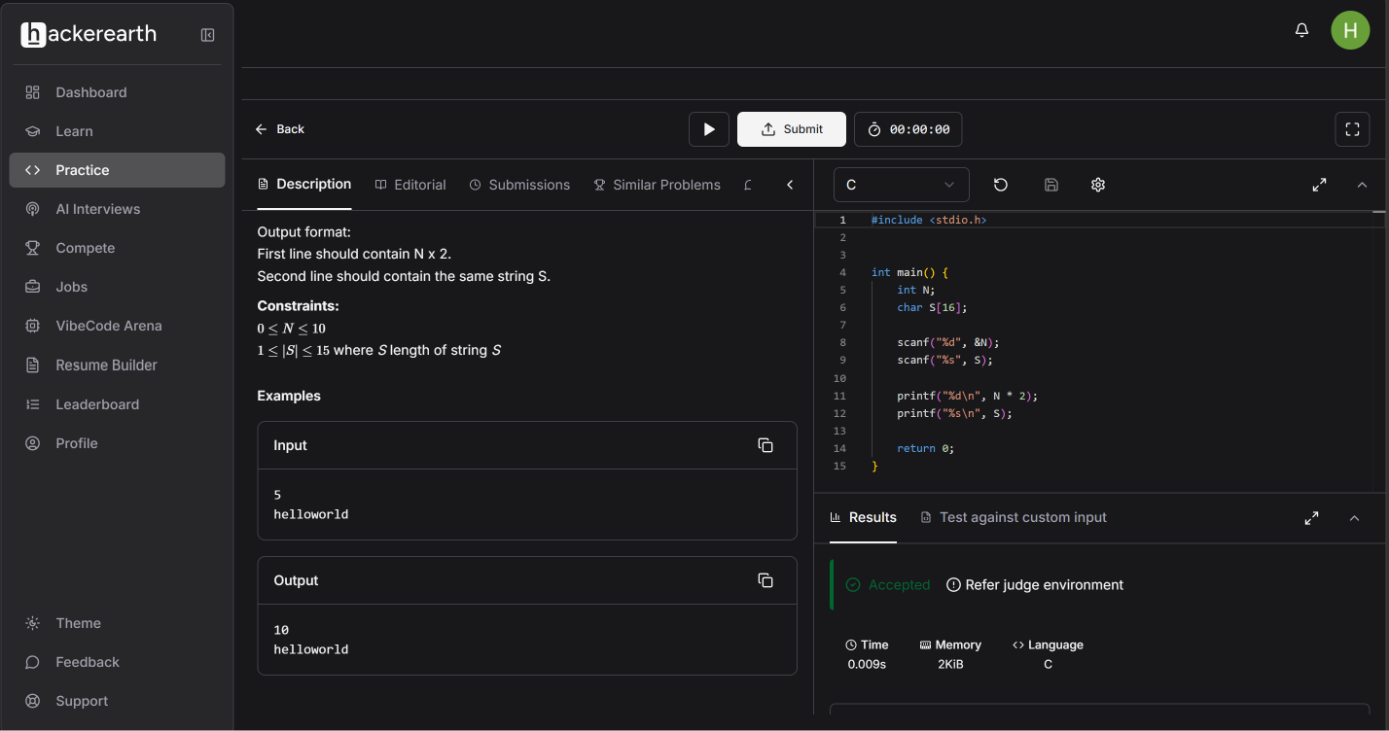

2. Solve Me First | HackerRank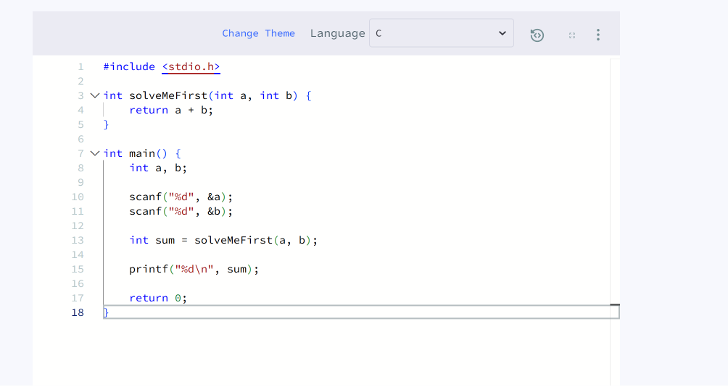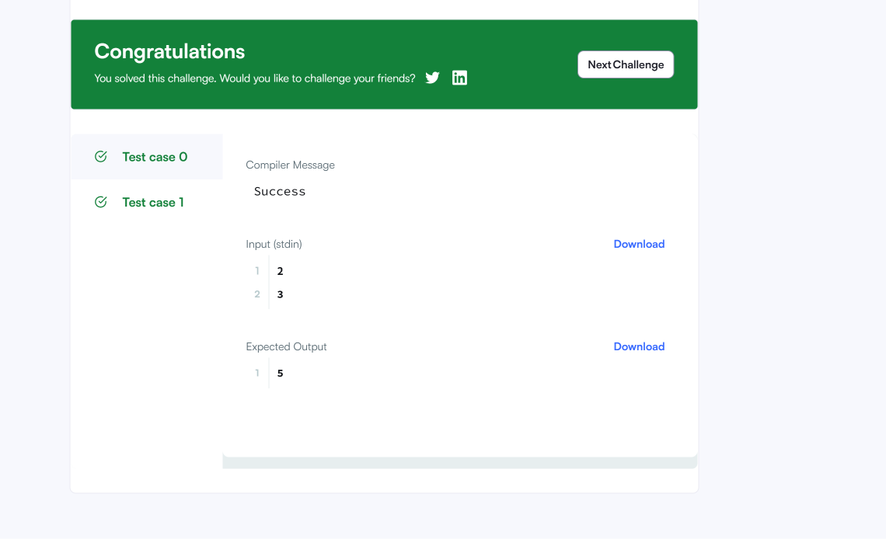

3. Add Two Integers - LeetCode
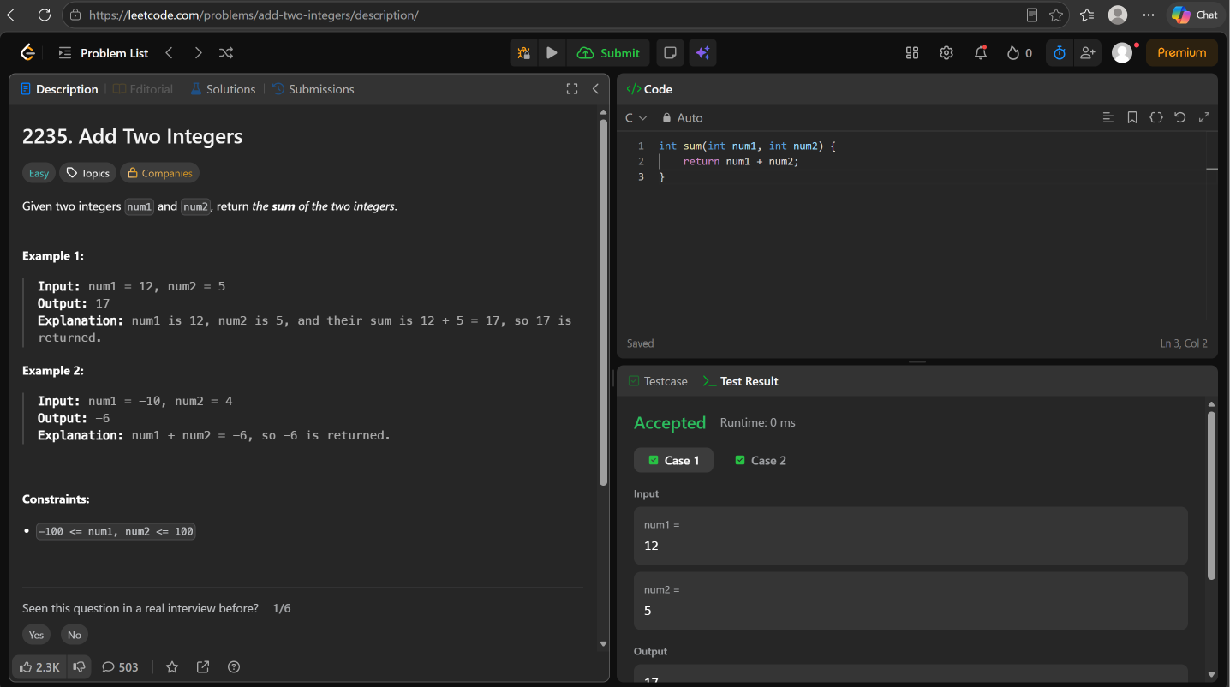

4. Calculate Delayed Arrival Time - LeetCode
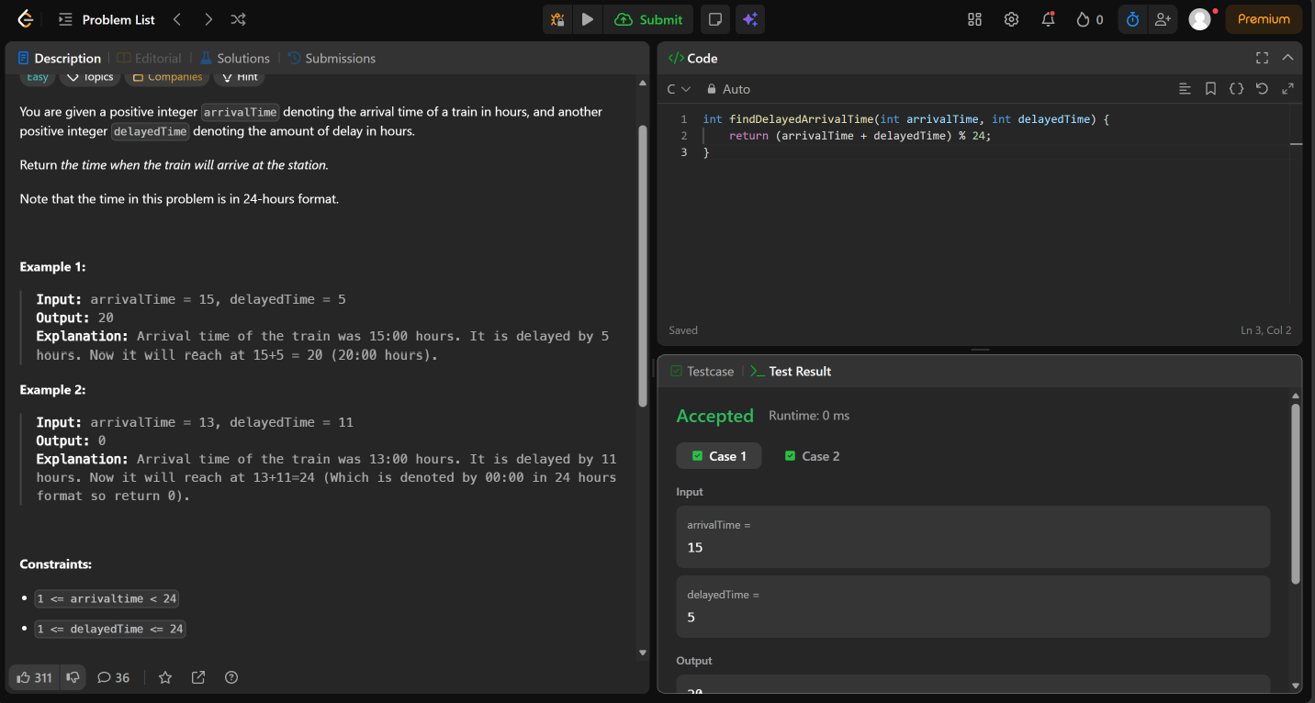

5. Total Distance Traveled - LeetCode


